1. A list of all the bugs/defects/flaws found in the UI

* Able to enter & add employee with numeric/special characters for First & Last name fields. Employee is added & saved without error.
* Able to enter as many dependents in the dependency field.

Ex: 1233333333 Then, clicking Add Employee doesn’t show any error message.

* Click Add on Add Employee pop up box without entering any data in any of the fields; does not show any error. Ex: Required fields.
* No field limits for any 3 fields when entered long first/last name. NO error is shown when I tried to enter a long First/Last name and click Add.
* No error is shown when entered alpha & special characters in the Dependants field & click Add/Update.
* Added employees are not displayed in alphabetical order.
* When Benefit Dashboard times out; refreshing screen doesnt navigate back to Login page.

1. Steps to reproduce first 3 bugs/defects/flaws from the list

* Able to enter & add employee with numeric/special characters for First & Last name fields. Employee is added & saved without error.

Login to Benefit Dashboard.

Click Add button.

Enter alpha/numeric characters in First & last name field.

Enter valid # of dependent.

Click Add.

Employee is added and saved without error.

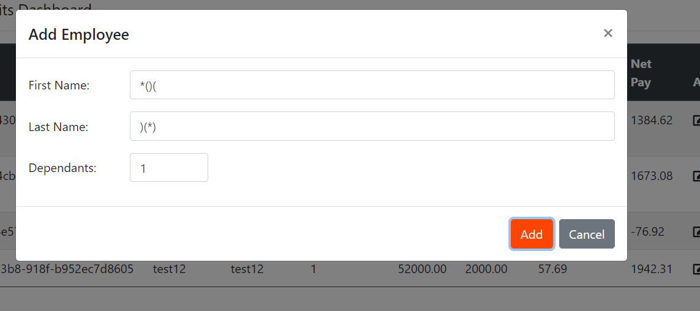



* Able to enter as many dependents in the dependency field.

Ex: 1233333333 Then, clicking Add Employee doesn’t show any error message for maximum that is allowed.

Login to Benefit Dashboard.

Click Add button.

Enter alpha characters in First & last name field.

Enter 1233333333 in dependent field.

Click Add.

System doesn’t show any error message. User is still on Add Employee screen.

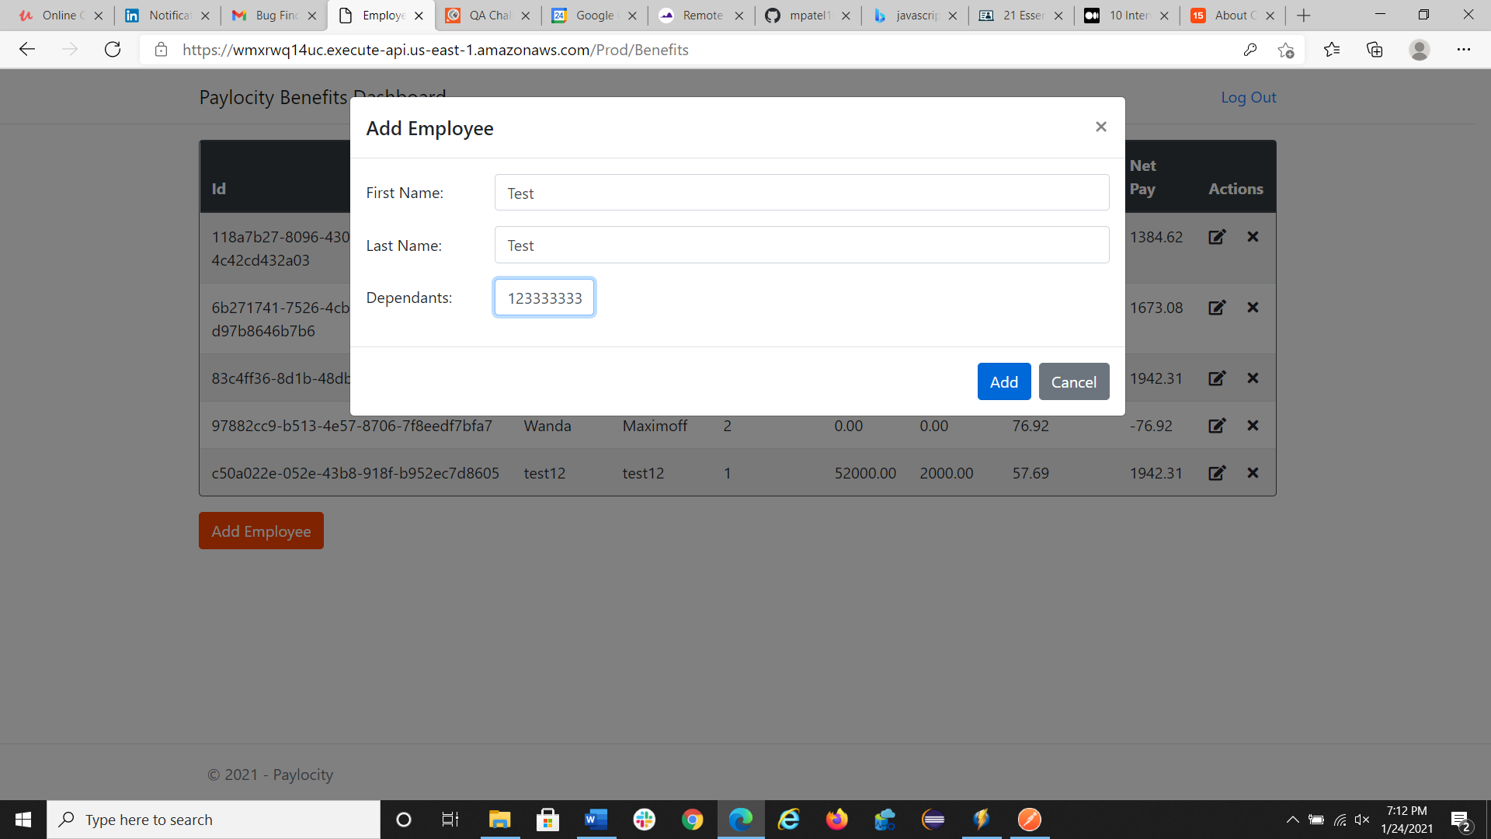

* Click Add on Add Employee pop up box without entering any data in any of the fields; does not show any error. Ex: Required fields.

Login to Benefit Dashboard.

Click Add button.

Click Add on Add Employee pop up box without entering any data in any of the fields.

System doesn’t show any error message. User is still on Add Employee screen.

